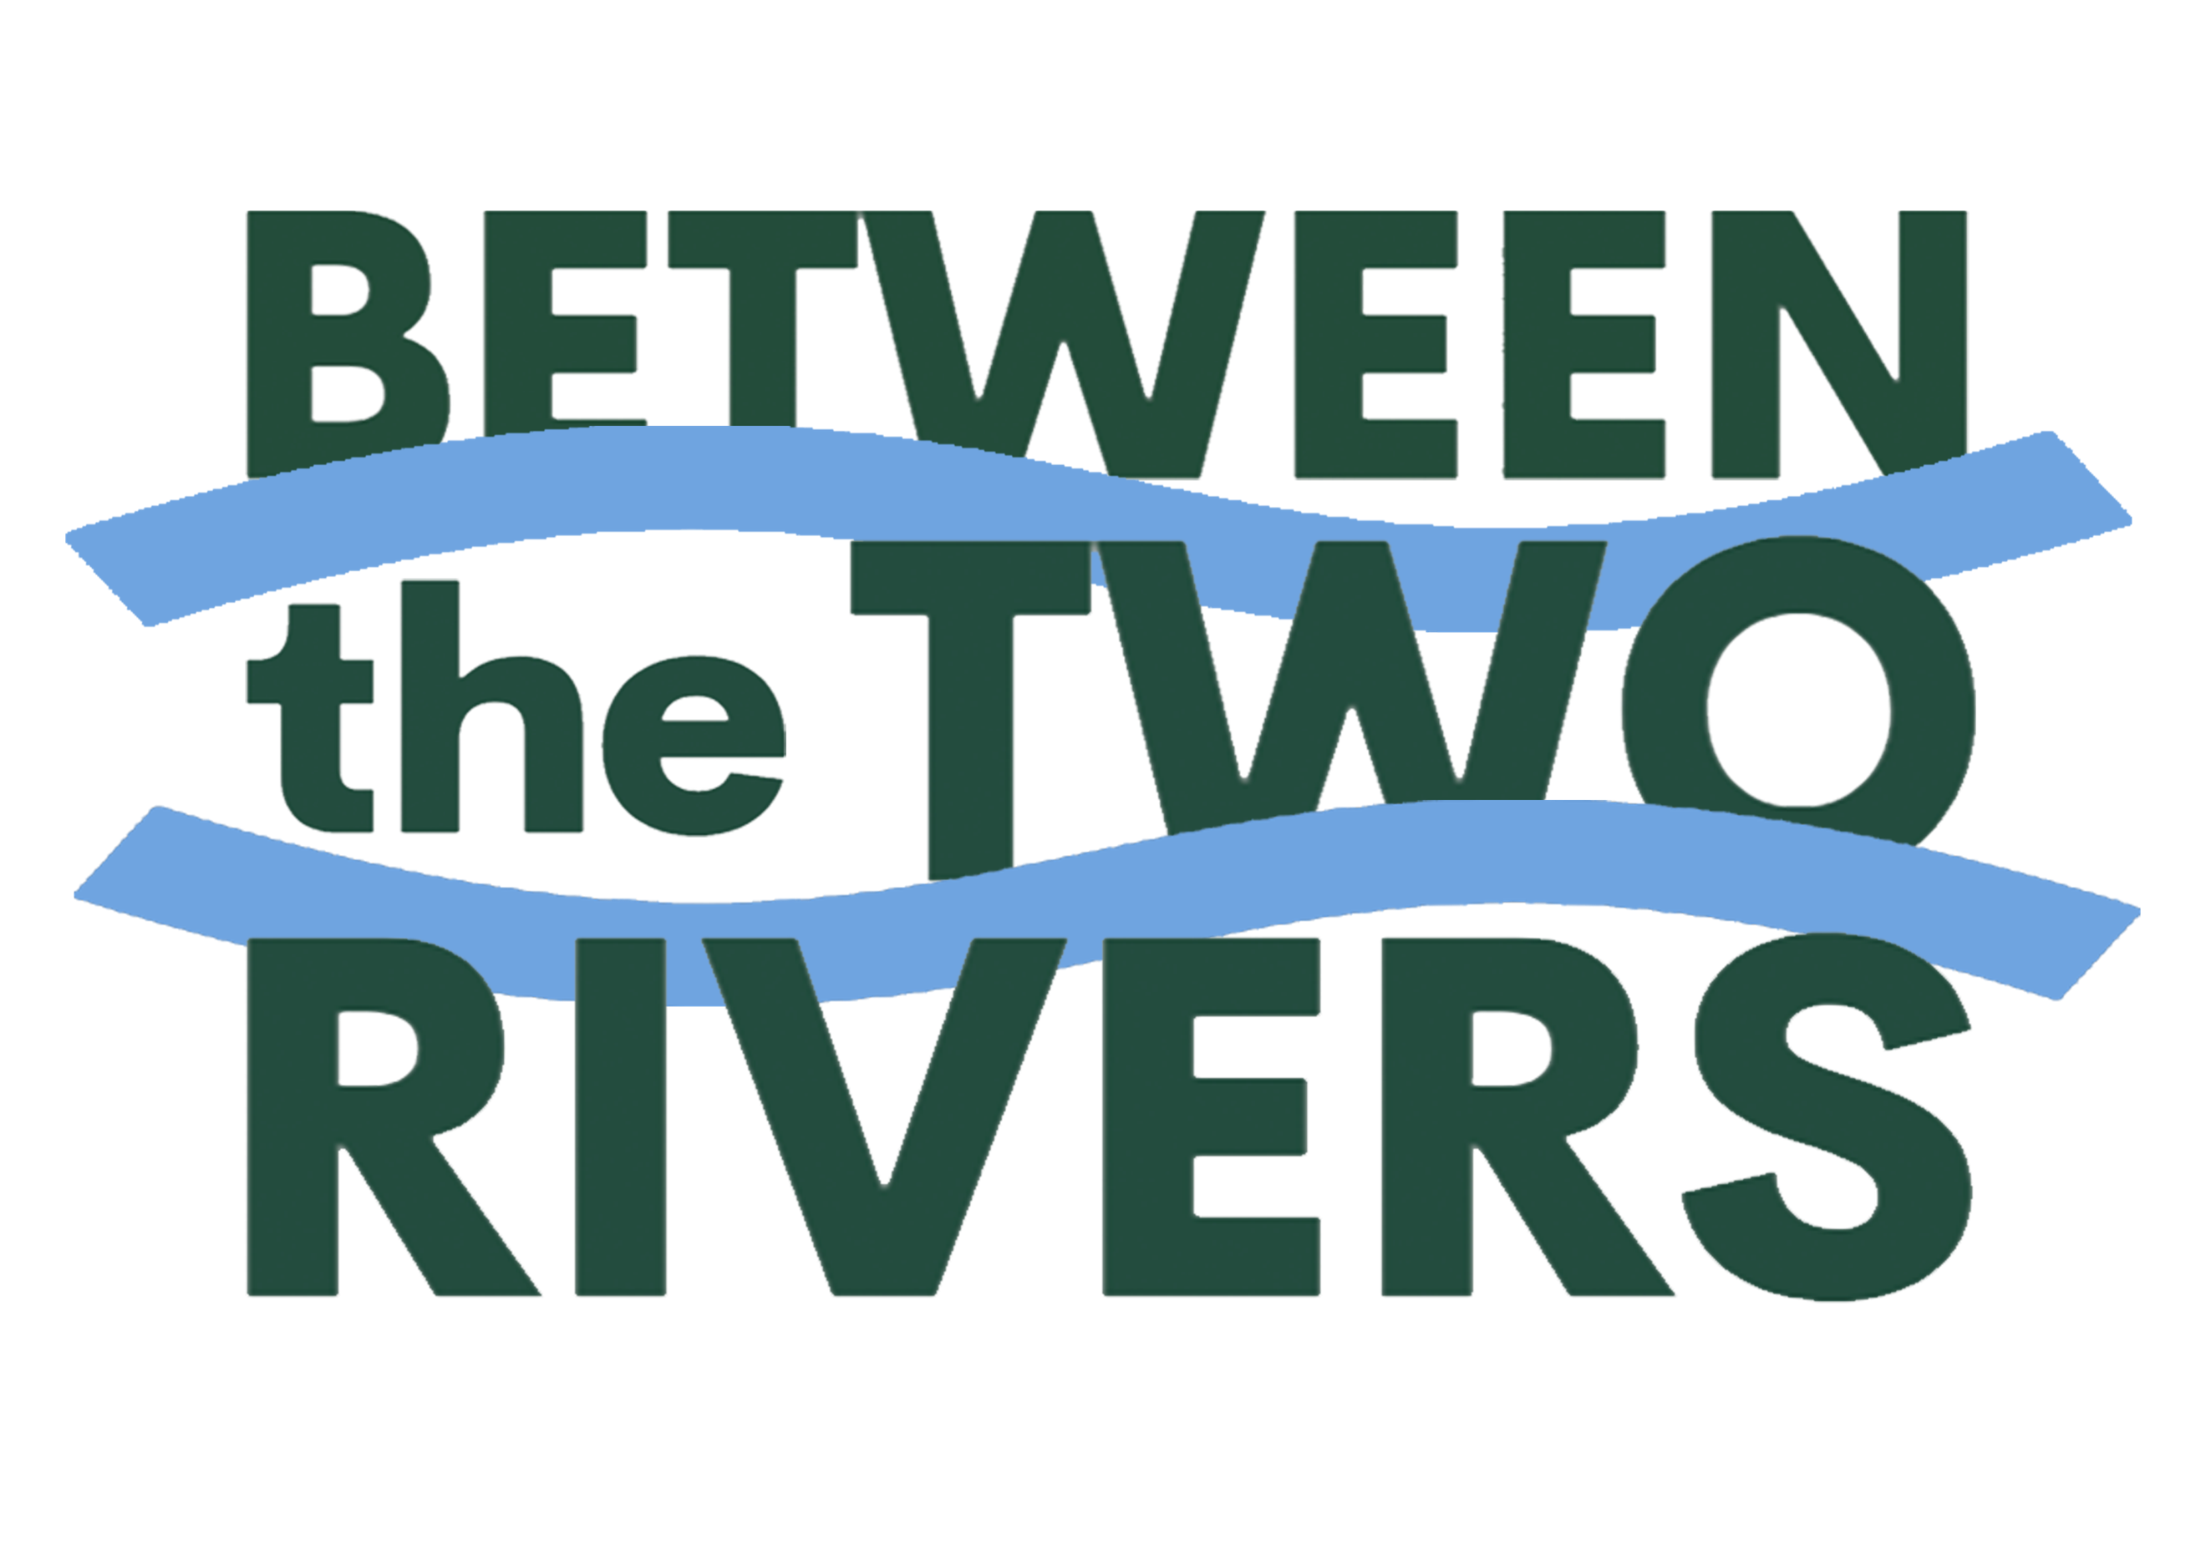
Between the Two Rivers Community Catchment Collective Inc
Nomination Form for the Committee
Nominations for the Committee of Between the Two Rivers Community Catchment Collective Inc (B2R) must be from members of B2R. You can become a member here. Members may self-nominate or be nominated by another member.
I _________________________________________________(nominator),
being a member of the Between the Two Rivers Community Catchment Collective Inc, hereby nominate _______________________________________________ (name of nominee) who is also a member of the Between the Two Rivers Community Catchment Collective Inc.
Signed (nominator) _____________________________________________________
Dated this _________________ day of ________________ , ______.
I (full name of nominee) ___________________________________________________
hereby accept nomination as a Member of the Committee of Between the Two Rivers Community Catchment Collective Inc for 2024-2027.
Signed (nominee) ______________________________________________________
Dated this ________________ day of ________________ , ______.
Please return to: Stephanie Howard, email: betweenthe2rivers@gmail.com
No later than 4pm on 23 August 2024

